**Money Matters: A Personal Finance Management App**

**Team members:**

**Devashri M-** 439C190AB51D29EBB714828BE97B8C2B

**Swetha S** -5D0265D08D058438FB947C5A965BDE8E

**Selvarani K** – 294D1332579B6D298F745A218CE53B0C

**Paranjothi S** -3C8B0B3DB874CB0B21049F9EE80092E5

Money Matters: A Personal Finance Management App

Project Description:

The app allows user to keep track of their expenses and accounts, and provides an overview of their financial status.Users can set a budget for various expenses and view their progress towards it.

Architecture:

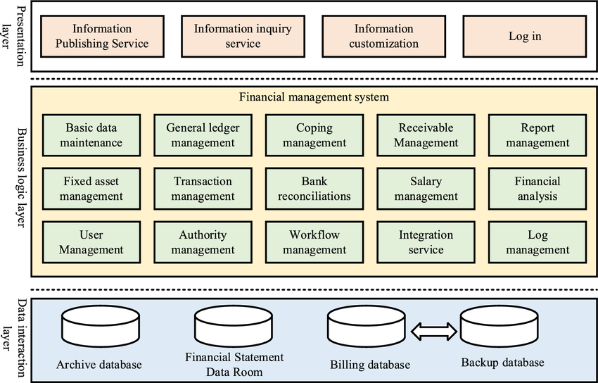

Learning Outcomes :

By end of this project:

You’ll be able to work on Android studio and build an app.

You’ll be able to integrate the database accordingly.

Project Workflow:

Users register into the application.

After registration , user logins into the application.

User enters into the main page

Note:

To complete the project you need to finish up the tasks listed below:

Tasks:

* Required initial steps
* Creating a new project.
* Adding required dependencies.
* Creating the database classes.
* Building application UI and connecting to database.

Required Initial Steps

Required initial steps

https://developer.android.com/studio/install

Creating A New Project

Creating a new project

Step 1 : Android studio > File > New > New Project > Empty Compose Activity

Step 2 : Click on Next button.

Adding Required Dependencies

Adding required dependencies

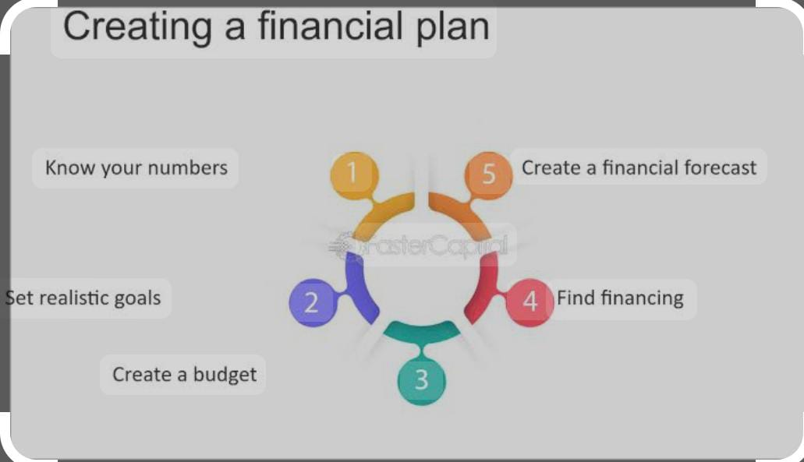

This milestone explains about adding required dependencies.

Gradle Scripts > Build.Gradle(Module :App)

Gradle scripts > build.gradle(Module :app)

Adding Room Dependencies

Adding room dependencies

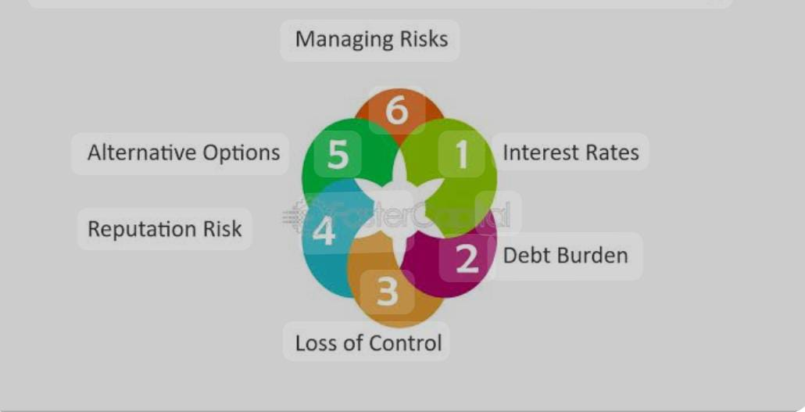

Add the below code in dependencies

// Adding Room dependencies

implementation 'androidx.room:room-common:2.5.0'

implementation 'androidx.room:room-ktx:2.5.0'

Creating The Database Classes For User Login And Registration.

This milestone explains about Creating the database classes for user login and registration.

Create User Data Class



Create User data class

https://github.com/smartinternz02/Expense-Tracker-App/blob/master/app/src/main/java/com/example/expensestracker/User.kt

Create An UserDao Interface

Create an UserDao interface

https://github.com/smartinternz02/Expense-Tracker-App/blob/master/app/src/main/java/com/example/expenhttps://github.com/smartinternz02/Expense-Tracker-App/blob/master/app/src/main/java/com/example/expensestracker/Items.ktsestracker/UserDao.kt

Create An UserDatabase Class

Create an UserDatabase class

https://github.com/smartinternz02/Expense-Tracker-App/blob/master/app/src/main/java/com/example/expensestracker/UserDatabase.kt

Create An UserDatabaseHelper Class

Create an UserDatabaseHelper class

https://github.com/smartinternz02/Expense-Tracker-App/blob/master/app/src/main/java/com/example/expensestracker/UserDatabaseHelper.kt

Creating The Database Classes For Item Name, Quantity And Cost

This milestone explains about Creating the database classes for item name, quantity and cost

Create Items Data Class

Create Items data class

https://github.com/smartinternz02/Expense-Tracker-App/blob/master/app/src/main/java/com/example/expensestracker/Items.kt

Create ItemsDao Interface

Create ItemsDao interface

https://github.com/smartinternz02/Expense-Tracker-App/blob/master/app/src/main/java/com/example/expensestracker/ItemsDao.kt

Create ItemsDatabase Class

Create ItemsDatabse class

https://github.com/smartinternz02/Expense-Tracker-App/blob/master/app/src/main/java/com/example/expensestracker/ItemsDao.kt

Create ItemsDatabaseHelper Class

Create ItemsDatabaseHelper class

https://github.com/smartinternz02/Expense-Tracker-App/blob/master/app/src/main/java/com/example/expensestracker/ItemsDatabaseHelper.k

Creating The Database Classes For An Amount

This milestone explains about Creating the database classes for an amount

Building Application UI And Connecting To Database

This milestone explains about Building application UI and connecting to database

Modifying AndroidManifest.Xml

Modifying AndroidManifest.xml

https://github.com/smartinternz02/Travel-Plan-App/blob/master/app/src/main/AndroidManifest.xml

Running The Application

This milestone explains about running the application.

Introduction

Managing personal finances effectively is a crucial aspect of modern life. In an era where financial decisions can greatly impact our present and future well-being, having a reliable tool to assist in financial management is invaluable. This article introduces Sly Spend; an innovative AI-powered personal finance management app designed to empower individuals in making informed financial choices. Sly Spend leverages the capabilities of artificial intelligence and data analysis to provide users with comprehensive insights into their financial activities. By seamlessly integrating with various financial accounts, such as bank accounts, credit cards, and investment portfolios, the app offers users a holistic view of their financial health, empowering them to make more informed decisions and take control of their money. The core strength of Sly Spend lies in its AI algorithms, which continuously analyze user data to generate personalized recommendations and insights. By utilizing machine learning techniques, the app can identify spending patterns, detect potential areas for improvement, and provide tailored suggestions to optimize financial outcomes.

Methodology

***Data Collection***

The data collection process for Sly Spend involves obtaining financial transaction data from users' connected accounts. Users are required to link their bank accounts, credit cards, and investment portfolios to the app. The app uses secure APIs provided by financial institutions to establish a connection and retrieve transactional data. This data includes details such as transaction amounts, dates, merchant names, and transaction categories.

***Data Preprocessing***

Once the transaction data is retrieved, it undergoes a preprocessing phase. During this phase, the data is cleaned, normalized, and standardized to ensure consistency and accuracy. Data cleaning involves removing duplicates, handling missing values, and resolving any inconsistencies or discrepancies in the data. The preprocessing step ensures that the subsequent analysis is based on reliable and consistent data.

***Machine Learning and AI Algorithms***

Sly Spend utilizes machine learning and AI algorithms to analyze the preprocessed financial transaction data and generate personalized insights and recommendations. These algorithms employ various techniques, such as supervised and unsupervised learning, natural language processing, and anomaly detection.

***Advantages***

Simplicity and interpretability: Linear regression provides straightforward interpretations of the relationship between variables.

Computational efficiency: Linear regression is computationally efficient and can handle large datasets with ease.

Suitable for simple relationships: Linear regression is effective when there is a linear relationship between the input features and the target variable.

For example, based on users' spending patterns, the app suggested potential cost-saving measures, such as switching to more affordable service providers or identifying subscription services that were no longer utilized. Sly Spend also offered personalized investment suggestions based on users' risk profiles and financial goals, aiming to help users maximize returns while maintaining an appropriate level of risk.

Feedback from users indicated that the personalized recommendations provided by Sly Spend were highly beneficial, enabling them to make more informed financial decisions and improve their overall financial well-being.

Based on the comparative study, the Neural Network model outperforms Linear Regression and Random Forest in terms of accuracy score. The Neural Network's ability to learn complex patterns and relationships within the financial transaction data contributes to its superior performance. Its multi-layer structure and non-linear activation functions enable it to capture intricate dependencies between input features and target variables.



**Accuracy of Linear model**



**Accuracy of Neural Networks**





Transform to open science



Conclusion

The implementation of Sly Spend, an AI-powered personal finance management app, has demonstrated its effectiveness in empowering individuals to take control of their finances and improve their financial well-being. Through the integration of advanced AI algorithms, user-friendly interfaces, and a commitment to privacy and security, Sly Spend offers a comprehensive solution for managing personal finances

**Thank you…..!**